|  |  |
| --- | --- |
| Project Name | CustomerCare Registry |
| Team ID | **PNT2022TMID17282** |
| ProjectDomain | Cloud Application Development |

**PerformanceMetrics:**

CPUusage:

* + - Since all the operations run using Flask is in server-side, the client (browser) need not worryabouttheCPUusage.Just renderingthe page,staticcontentstake place inthe client-side.

Memory for client-side functions (Javascript) is allocated using heap. It can be eitherincreased 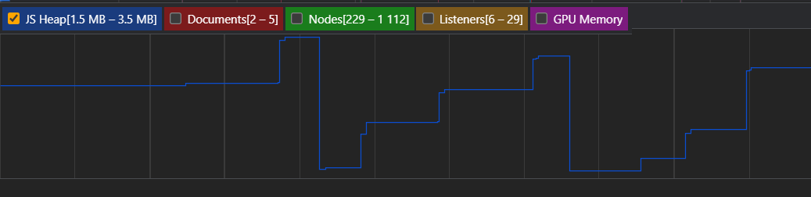

basedupontherequirementorremovedfromthe heap.

Errors:

* + - Since all the backend functions are done using flask, any exceptions / errors rising are well-handled.Thoughtheyappear,user’sinteractionwiththesiteisnotaffectedinany way

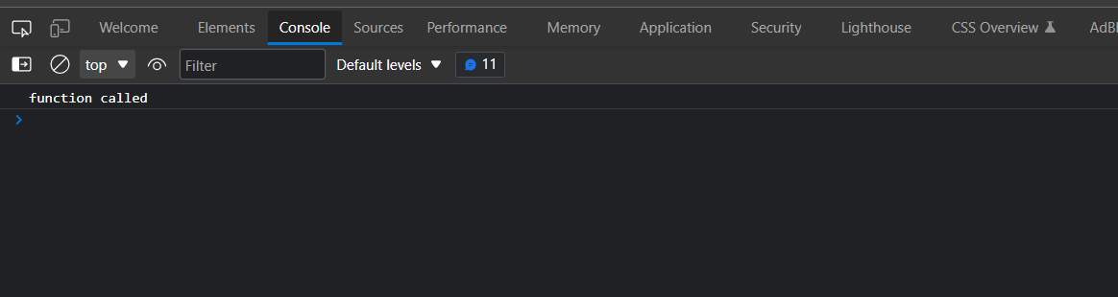

LatencyandResponsetime:

It takes lessthan a second to load a page in the client.From this it isevident that there is low latency

